**Irish Senthilkumar 16342613 CT331 Assignment 2**

**Github Link:** [**https://github.com/16342613/CT331-Assignment-2**](https://github.com/16342613/CT331-Assignment-2)

**Question 1:**

**(a)**

#lang racket

; Defining our methods

(define (part1 object1 object2)

(cons object1 object2)

)

(define (part2 number1 number2 number3)

(cons number1 (cons number2 (cons number3 empty)))

)

(define (part3 str1 num1 listNum1 listNum2 listNum3)

(cons str1 (cons num1 (cons (cons listNum1 (cons listNum2 (cons listNum3 empty))) empty)))

)

(define (part4 str1 num1 listNum1 listNum2 listNum3)

(list str1 num1 (list listNum1 listNum2 listNum3))

)

; Our methods being called

(part1 "Programming" "Paradigms")

(part2 1 2 3)

(part3 "Hello" 1 2 3 4)

(part4 "World" 5 6 7 8)

(append '("YEEEHAW") '(99) '((98 99 100))) ; PART 5

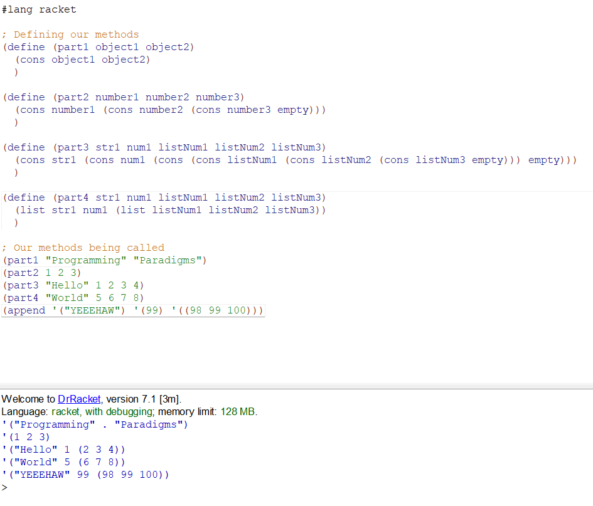

**(b)**

* For part 1, cons is used to make a con pair with the 2 input parameters.
* For part 2, a nested cons is used to create a list. We keep using nested cons until we get to the last element in the list, where we use a con pair of the last element and empty, since cons requires 2 input parameters.
* For part 3, we once again use nested cons, but here we use a double nested cons to get a nested list inside our list.
* For part 4, we use the list function to make the super-list, and another list function inside the super-list to make the sub-list.
* For part 5, we just append list items, whatever they may be, to the super-list.

**Question 2:**

#lang racket

; Provide access by unit test file

(provide ins_beg)

(provide ins_end)

(provide count_top_level)

(provide count_instances)

(provide count_instances_tail_recursion)

(provide count_instances_tr)

; Part A method

(define (ins_beg element list)

(cons element list)

)

; Part B method

(define (ins_end element list)

(cons list element)

)

; Part C method

(define (count_top_level list)

(cond [(empty? list) 0]

[(list? (car list)) (count_top_level (cdr list))]

[(+ 1 (count_top_level (cdr list)))]

)

)

; Part D method

(define (count_instances list element)

(cond [(empty? list) 0]

[(equal? (car list) element) (+ 1 (count_instances (cdr list) element))]

[(count_instances (cdr list) element)]

)

)

; Part E method

(define (count_instances_tail_recursion list element)

(count_instances_tr list element 0)

)

(define (count_instances_tr list element total)

(cond [(empty? list) total]

[(equal? (car list) element) (count_instances_tr (cdr list) element (+ total 1))]

[(count_instances_tr (cdr list) element total)]

)

)

; Part F method (NOT WORKING)

(define (count_instances_deep list element)

(cond [(empty? list) 0]

[(equal? element (car list)) (+ 1 (count_instances_deep (cdr list)))]

[(list? (car list)) (+ (count_instances_deep element (car list)) (count_instances_deep element (cdr list)))]

[(count_instances_deep element (cdr list))]

)

)

; Function tests

(ins_beg 'a '(b c d))

(ins_beg '(a b) '(b c d))

(ins_end 'a '(b c d))

(ins_beg '(a b) '(b c d))

(count_top_level '((a b) (b c) d e f))

(count_top_level '(a b c (d e) f (g h)))

(count_instances '(a b c d e a) 'a)

(count_instances '(1 2 1 5 5 1) 1)

(count_instances_tail_recursion '(1 3 1 1 2) 1)

;(count_instances_deep '(2 (1 1) 2 3) 1)

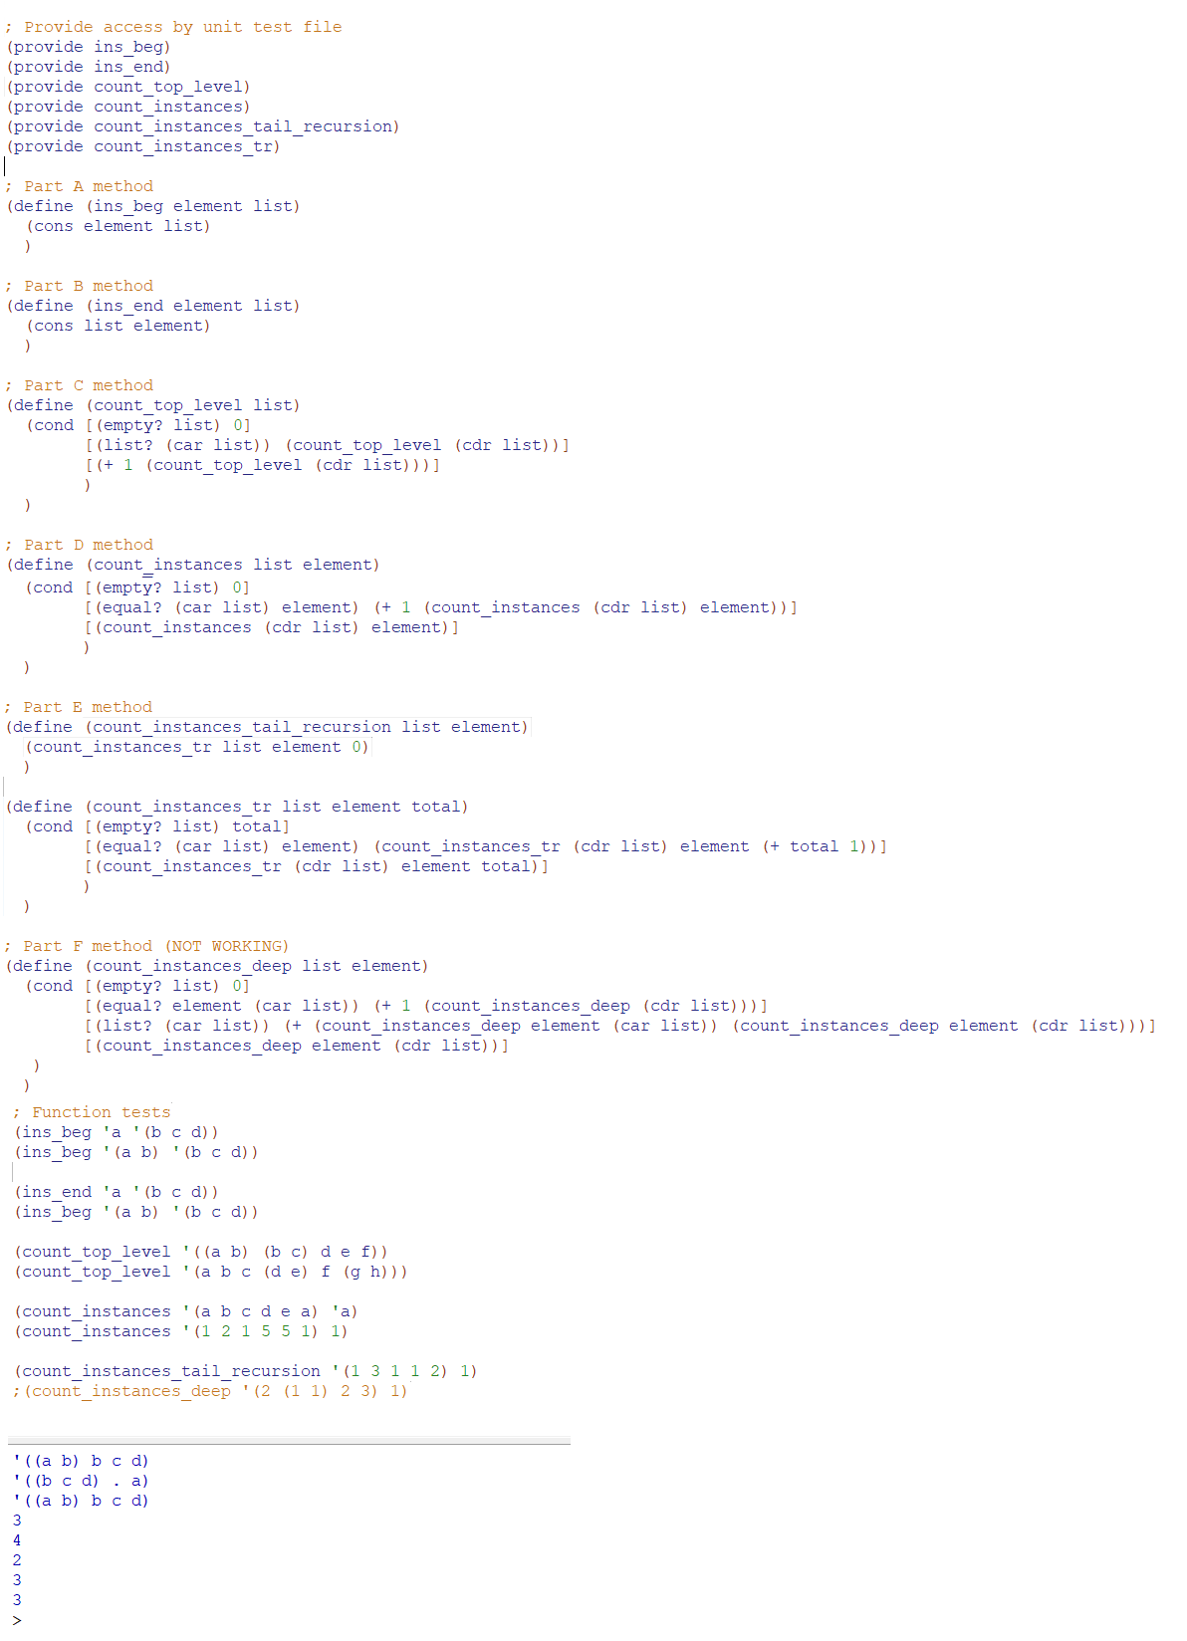

**Question 3:**

#lang racket

; Structure is (Left, Element, Right)

; Part A method

; ???

; Part B method

(define (searchTheTree element tree) ; Our method parameters

(cond [(empty? tree) #f] ; If the tree is null, return false

[(equal? element (cadr tree)) #t] ; If the element is found, return true;

[(< element (cadr tree)) (searchTheTree element (car tree))] ; Recursively go through the left subtree if the element to find is less than the current node's element

[(> element (cadr tree)) (searchTheTree element (caddr tree))] ; Recursively go through the right subtree if the element to find is greater than the current node's element

)

)

; Part C method

(define (insertIntoTree element tree) ; Our method parameters

(cond [(empty? tree) (list empty element empty)] ; If the tree is null, display an tree with the element inserted

[(equal? element (cadr tree)) tree] ; If the element is equal to another element in the tree, display the tree

[(< element (cadr tree)) (list (insertIntoTree element (car tree)) (cadr tree) (caddr tree))] ; Recursively go through the left subtree if the element to insert is less than the current node's element

[(> element (cadr tree)) (list (car tree) (cadr tree) (insertIntoTree element (caddr tree)))] ; Recursively go through the right subtree if the element to insert is greater than the current node's element

)

)

; Part D method

(define (insertListIntoTree list tree)

(cond [(empty? list) tree] ; If the list is empty, print the tree i.e. we are finished

[insertListIntoTree (insertIntoTree (car list) tree) (cdr list)] ; Calling both insert and insert as list methods recursively to add the list to the tree

)

)

; Part E method

; ???

; Part F method

; ???

; Test functions

;(insertIntoTree 1 '((() 5 ()) 10 (() 15 ())))

;(searchTheTree 5 '((() 5 ()) 10 (() 15 ())))

;(searchTheTree 12 '((() 5 ()) 10 (() 15 ())))

;(insertListIntoTree '(1 2 3 4 11 12 13 14) '((() 5 ()) 10 (() 15 ())))

